**Coffee Shop Sales**

Transaction records for Maven Roasters, a fictitious coffee shop operating out of three NYC locations. Dataset includes the transaction date, timestamp and location, along with product-level details.

**Recommended Analysis**

1 - How have Maven Roasters sales trended over time?

2 - Which days of the week tend to be busiest, and why do you think that's the case?

3 - Which products are sold most and least often? Which drive the most revenue for the business?

**Data Preview**

* **transaction_id** : Unique sequential ID representing an individual transaction
* **transaction_date** : Date of the transaction (MM/DD/YY)
* **transaction_time** : Timestamp of the transaction (HH:MM:SS)
* **transaction_qty** : Quantity of items sold
* **store_id** : Unique ID of the coffee shop where the transaction took place
* **store_location** : Location of the coffee shop where the transaction took place
* **product_id** : Unique ID of the product sold
* **unit_price** : Retail price of the product sold
* **product_category** : Description of the product category
* **product_type** : Description of the product type
* **product_detail** : Description of the product detail

Q) How have Maven Roasters sales trended over time?

SELECT MONTH(transaction_date) as Month_num,

DATENAME(MONTH, transaction_date) as 'Month',

ROUND(SUM(unit_price * transaction_qty),2) as Total_Sales

FROM Coffee_Shop_Sales

GROUP BY DATENAME(MONTH, transaction_date),

MONTH(transaction_date)

ORDER BY Month_num;

Solution

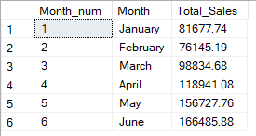

Q) Which days of the week tend to be busiest, and why do you think that's the case ?

SELECT DATEPART(DW, transaction_date) as day_num,

DATENAME(WEEKDAY, transaction_date) as day_of_week,

ROUND(SUM(unit_price * transaction_qty),2) as Total_sales

FROM Coffee_Shop_Sales

GROUP BY DATENAME(WEEKDAY, transaction_date),

DATEPART(DW, transaction_date)

ORDER BY Total_sales DESC;

Solution

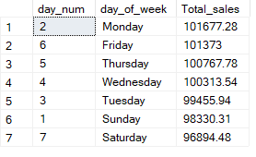

The Most Busiest day is Monday, because the most people have holiday on Sunday and Saturday. Monday is the new starting day of the work.

Q) Which products are sold most and least often? Which drive the most revenue for the business?

SELECT product_category,

SUM(transaction_qty) as Product_sold_count,

ROUND(SUM(transaction_qty * unit_price),2) as Total_revenue

FROM Coffee_Shop_Sales

GROUP BY product_category

ORDER BY Product_sold_count;

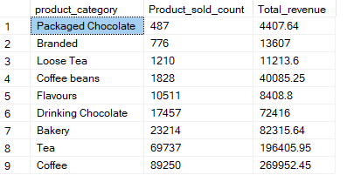

The product most sold is Coffee and the least often is Packged Chocolate as per the revenue.

Q) Find the Total Sales by Hours?

SELECT

DATEPART(HOUR ,transaction_time) as Peek_hour,

ROUND(SUM(transaction_qty * unit_price),2) as Total_revenue

FROM Coffee_Shop_Sales

GROUP BY DATEPART(HH,transaction_time)

ORDER BY Peek_hour

Solution

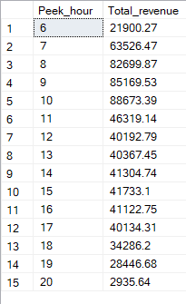

Q) What is the Total Revenue By Store along with its location ?

SELECT DISTINCT store_id,

store_location,

ROUND(SUM(transaction_qty * unit_price),2) as Total_revenue

FROM Coffee_Shop_Sales

GROUP BY store_id,store_location;

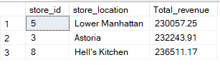

Q) Which product type has the maximum demand ?

SELECT

product_category,

product_type,

COUNT(product_type) as deamand_count

FROM Coffee_Shop_Sales

GROUP BY product_type,

product_category

ORDER BY deamand_count DESC;

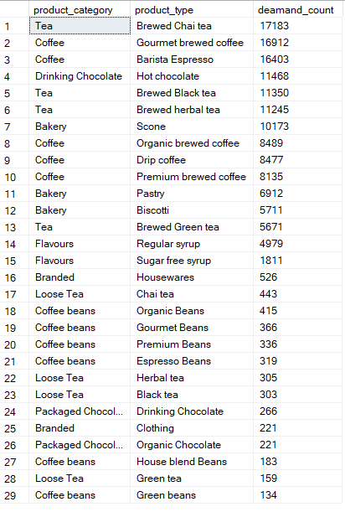

Q) Find the Minimum and Maximum unit price along with the category ?

SELECT product_category,

ROUND(MIN(unit_price),2) as Min_unit_price,

ROUND(MAX(unit_price),2) as Max_unit_price

FROM Coffee_Shop_Sales

GROUP BY product_category

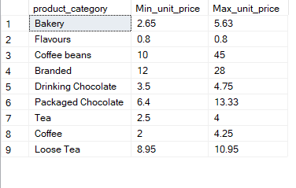

Q) Find the Previous Month Revenue ?

SELECT

ROUND(SUM(transaction_qty * unit_price),2) as Total_revenue

FROM Coffee_Shop_Sales

WHERE MONTH(transaction_date) = 5

